IT24102334-Thathsara.K.P.W.P.T

Lab-8

1.

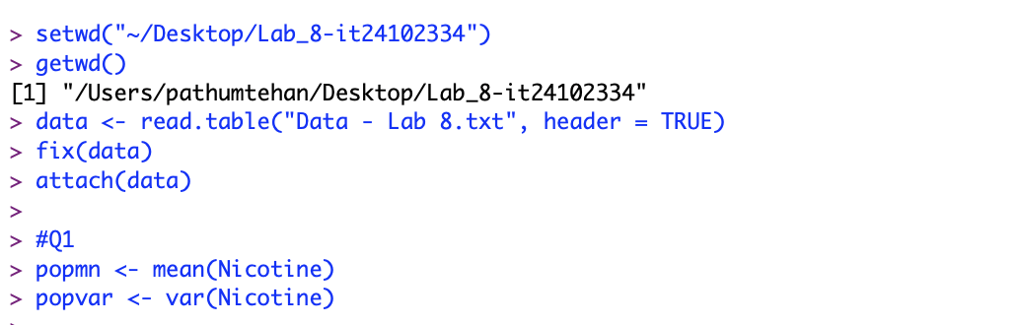

2.

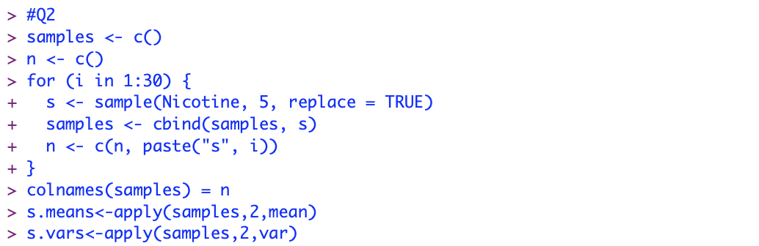

3.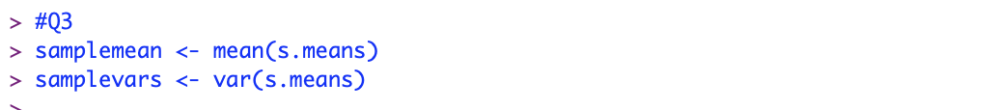

4.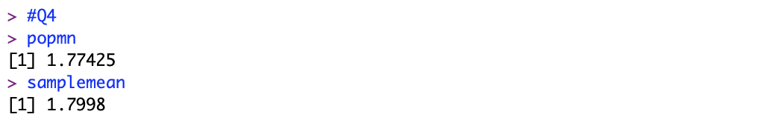

5.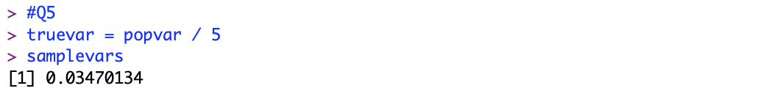

Exercise

1.

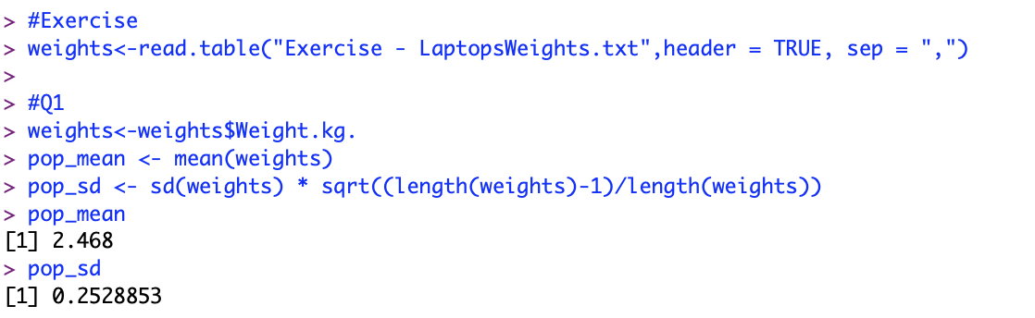

2.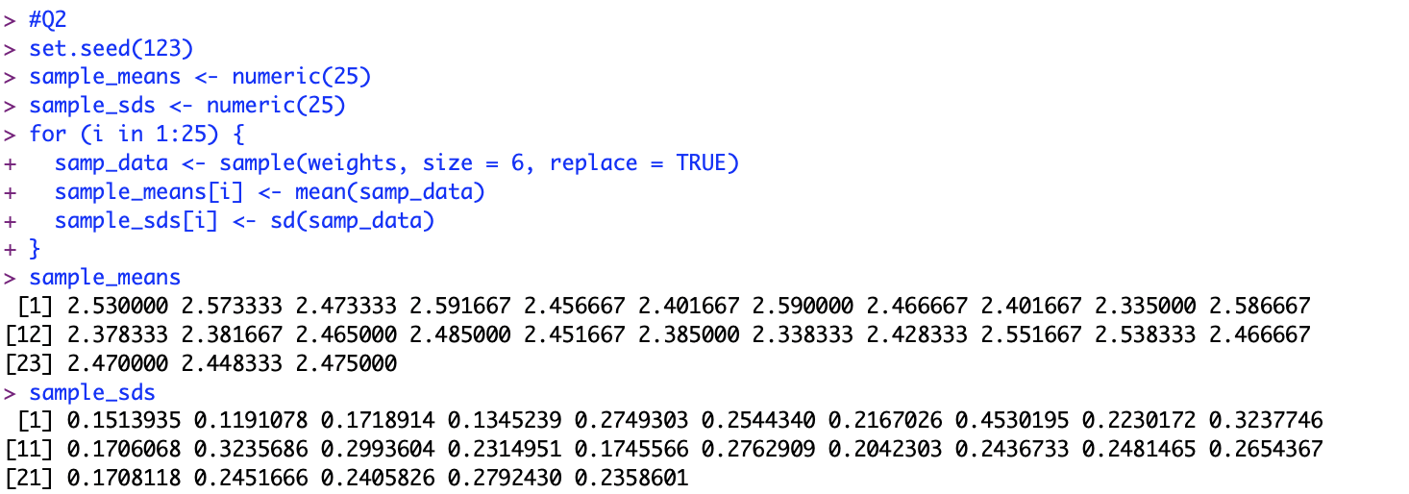

3.

